The Nucleus of a Cell

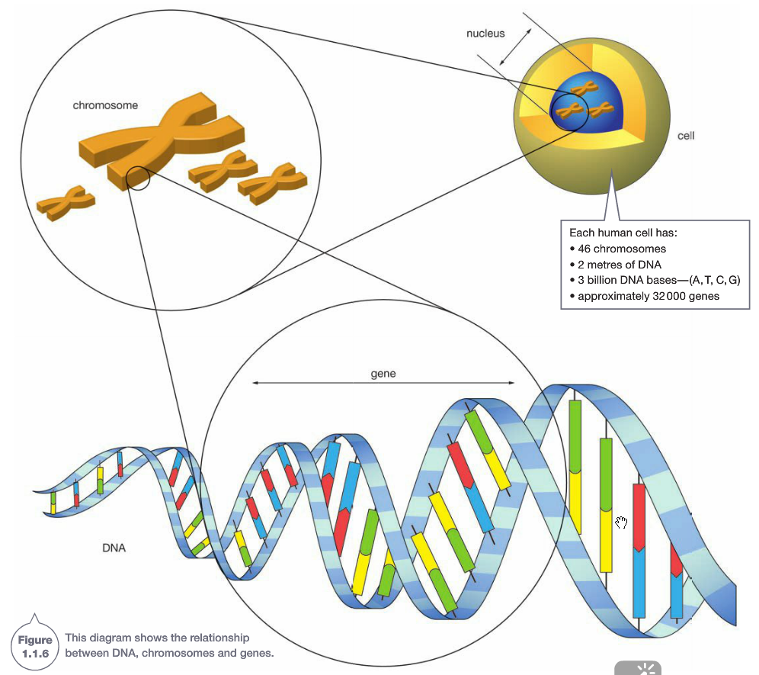
The nucleus can be thought of as the control centre of a cell. It contains information about how the cell functions, as well as information about the organism as a whole.

Inside the nucleus of a cell are structures called chromosomes. Chromosomes are only visible when the cell is undergoing cell division.

Genes are sections of chromosomes which determine the characteristics of the organism.

The Structure of DNA

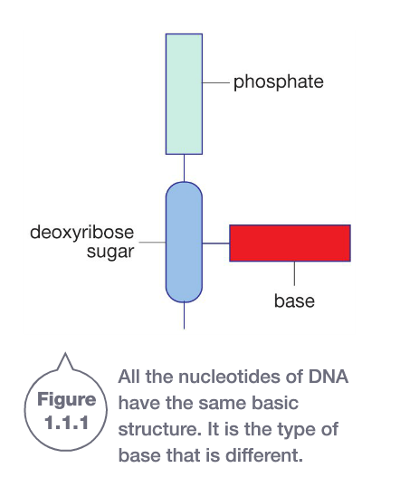
Chromosomes are made of a substance called deoxyribonucleic acid, or DNA for short. It is the sequence of the DNA in your chromosomes that makes up your genes and determines your characteristics.

DNA is a complex chemical compound. It is made up of molecules called nucleotides. The basic structure of a nucleotide is shown on the right. Nucleotides have three main parts: a phosphate group, a deoxyribose sugar and a nitrogen base.

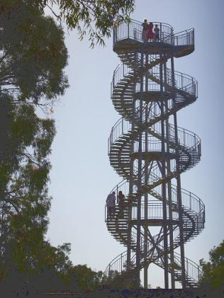
The nucleotides are arranged in a way that makes a double helix. A double helix is shaped like a twisted ladder, like the lookout tower in King’s Park.

The uprights of the ladder are made of alternating phosphate and sugar groups. The nitrogen bases pair up to form the rungs of the ladder.

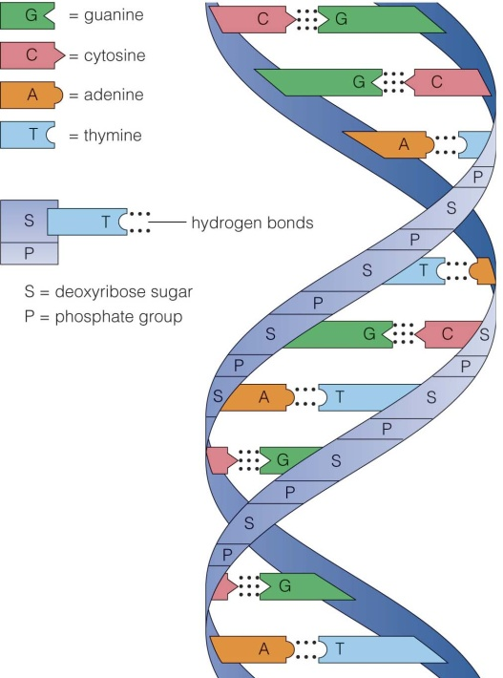
The Nitrogen Bases
There are four different nitrogen bases. They are Adenine, Cytosine, Guanine and Thymine. The four bases are represented by the first letter of its name, for example Adenine is represented by a capital A.

The chemical structure of each base means that it can only pair with one other base. These are called complementary base pairs. A pairs with T, and C pairs with G.

Questions
- What does DNA stand for?

- Nucleotides are the building blocks of DNA. What are the three parts of a nucleotide?

- In a DNA molecule, what do the letters A, T, C and G represent?

- DNA is often compared to a twisted ladder. Explain why this is a good comparison.

- What are complementary base pairs?

- Complete the strand of DNA below by writing in the complementary bases.

A C T A G C A T C G T G A

The Genetic Code
Organisms are different because the proteins in their cells are different. Proteins are made up of many smaller units called amino acids joined together in long chains.

The DNA provides a code for the cells to make proteins. Each set of three bases as you move down one side of the DNA molecule, codes for a specific amino acid. These sets of three bases are called codons.

The table below shows all the codons and the amino acids they code for. There is more than one codon for almost all of the 20 amino acids. There are also codons that stop the production of the protein.

DNA Code | Amino Acid | DNA Code | Amino Acid | DNA Code | Amino Acid | DNA Code | Amino Acid
AAA | phenylalanine | GAA | leucine | TAA | isoleucine | CAA | valine
AAG | phenylalanine | GAG | leucine | TAG | isoleucine | CAG | valine
AAT | leucine | GAT | leucine | TAT | isoleucine | CAT | valine
AAC | leucine | GAC | leucine | TAC | methionine | CAC | valine
AGA | serine | GGA | proline | TGA | threonine | CGA | alanine
AGG | serine | GGG | proline | TGG | threonine | CGG | alanine
AGT | serine | GGT | proline | TGT | threonine | CGT | alanine
AGC | serine | GGC | proline | TGC | threonine | CGC | alanine
ATA | tyrosine | GTA | histidine | TTA | asparagine | CTA | aspartic acid
ATG | tyrosine | GTG | histidine | TTG | asparagine | CTG | aspartic acid
ATT | STOP (ends the sequence) | GTT | glutamine | TTT | lysine | CTT | glutamic acid
ATC | STOP (ends the sequence) | GTC | glutamine | TTC | lysine | CTC | glutamic acid
ACA | cysteine | GCA | arginine | TCA | serine | CCA | glycine
ACG | cysteine | GCG | arginine | TCG | serine | CCG | glycine
ACT | tryptophan | GCT | arginine | TCT | arginine | CCT | glycine
ACC | tryptophan | GCC | arginine | TCC | arginine | CCC | glycine

Questions
- What materials does the genetic code eventually produce?

- A small section of DNA has the following sequence of bases.
TTA AGA CTC AAG GGG TCC TCA
  - How many amino acids does this section code for?
  - Use the table to work out the sequence of amino acids in the section of DNA.

  - A mutation changes the triplet AAG to GAG. How will this affect your answer to b?

  - Suppose this section of DNA is part of the gene that makes your blood clot when blood vessels have been damaged. Suggest what might happen if this mutation did occur?

All the cells in the body (except for the reproductive cells) contain the same number of chromosomes. The number of chromosomes contained in a body cell is called the diploid number. The gametes, or sex cells, of an organism contain half the number of chromosomes in a body cell. This is called the haploid number.

Chromosomes occur in pairs. One chromosome from each pair has come from the mother and the other from the father. Each chromosome has the same set of genes controlling the same set of characteristics.
Each species of animal and plant has a specific number of chromosomes. Some of them are shown below.
Plant | Number of Chromosomes |  | Animal | Number of Chromosomes
Fern | 1262 |  | Housefly | 12
Watermelon | 22 |  | Crayfish | 200
Wild oat | 14 |  | Orang-utan | 48
Corn | 20 |  | Cat | 38
Tomato | 24 |  | Cattle | 60
Rice | 24 |  | Fowl | 78
 |  |  | Fruit fly | 8
 |  |  | Human | 46
How many chromosomes exist in a

- Rice leaf cell?
- Crayfish antenna cell?
- Cat sperm?
- Tomato ova?
- Cow hair cells?
- Rice seed cell?
- Human heart cell?
- Human egg?
- Corn pollen?
- Chicken lung cell?

Questions
- Use the words in the box on the right to complete the sentences below.
  - ________________ are found in the nuclei of cells. They carry ______ which determine what an organism looks like and how it functions.
Bases
Chromosomes
DNA
Genes
Genome
Map
Sex cells
Fertilisation
  - Body cells contain pairs of chromosomes and ______________ contain only single chromosomes. When ___________ occurs, the single chromosomes in the sex cells form pairs in the cells of the new organism.
  - Chromosomes are made of ______. The sequence of ________ on the DNA determines which types of proteins will be made by the cell.
  - Scientists throughout the world have collaborated to ______ all the genes in the human _________.

- Chromosomes are found in

  - Sex cells only
  - All cells with a nucleus
  - Fertilised eggs only
  - Animal cells only

- A gene is

  - A chromosome
  - A molecule of DNA
  - Part of a chromosome
  - One base on a molecule of DNA

- What is DNA and where is it found in the body?

- What materials does the genetic code eventually produce?

- A small section of DNA has the following sequence of bases.
TTA AGA CTC AAG GGG TCC TCA
  - How many amino acids does this section code for?

  - Use the table on the previous page to work out the sequence of amino acids in the section of DNA.

  - A mutation changes the triplet AAG to GAG. How will this affect your answer to b?

  - Suppose this section of DNA is part of the gene that makes your blood clot when blood vessels have been damaged. Suggest what might happen if this mutation did occur?

DNA Activity: Create your own section of DNA
- Cut out 6 sugars and 5 phosphates.
- Starting with a deoxyribose sugar at the very top of the A3 sheet, glue a sugar-phosphate chain going down the page, matching up the symbols.
- Cut out the bases.
- Glue a base next to each sugar. It does not matter which order you put the bases in.
- Now you need to complete the complimentary base pairs. Glue the matching base next to the ones attached to the sugars.
- Complete your DNA model by adding the other sugar-phosphate chain.
- If you have time, you may wish to colour code your DNA model.

